

**EE 492 Senior Project 2**

**Final Report**

**Mehmet ÇINAR 13837189268**

**Atakan UZEL 10219159918**

**Hilal Sümeyra ÇEVİK 10541410602**

**İlknur Deniz BALOĞLU 42127124856**

**Date of Submission: 12/06/2022**

**Instructor Name: Aykut YILDIZ**

Table of Contents

**Acknowledgement** 3

**Abstract** 3

**Introduction** 4

**What did we achieved** 5

**Components**: 8

List of components: 9

**Assemblage** 11

**Application Flow Chart** 13

**Software** 13

**Map Design** 17

**Encountered Problems** 18

**Last Adjustments** 19

Adjustments’ Photos 20

**Conclusion** 24

**References** 25

# Acknowledgement

This project was made for the EE 492 course conducted by the Department of Electrical and Electronics Engineering at TED University. We would like to thank our dear teacher Aykut Yıldız for his advice and valuable contributions.

# Abstract

The continual evolution of automobile technology today, with the advancement of technology, promises to deliver more safety and convenience than prior technologies. It is vital to understand what an autonomous car is for this project to be understandable. A self-driving car is one that can recognize its surroundings and function without the need for human involvement.

The hardware and software of an autonomous vehicle are the primary objectives of this project. In other words, this is a project about automotive modeling that works. These are unique features that make driving easier and more convenient. To give a simple example, our project's goal is to create an Arduino-based tool that is low-cost, environmentally friendly, and functional. Furthermore, the major goal of this project is to create a tool that can conduct infrared line tracking, distance control, and picture processing functions all at the same time. As a result of these functions, the automobile can identify road lanes, road signals, barriers, and traffic signs, and it can finish the road driving safely by performing the necessary movements.

# Introduction

The major goals of this project, as stated in the summary section, are to track the line, to stop when you receive the stop instruction and then move again, and to make a U-turn. To carry out the commands, it was planned to use an Arduino Uno for distance control and line tracking, and a Raspberry Pi for image processing.

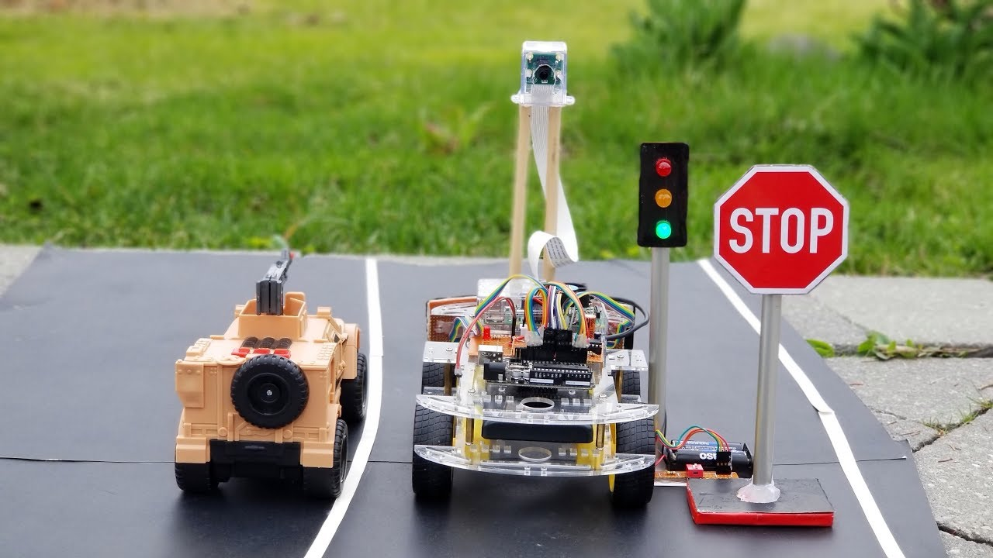For this purpose, the equipment to be utilized was decided after a review of the literature and research. Then, based on educational videos, our past projects and internship experience, we made progress in the project by learning how to use and install the Arduino Uno and Raspberry Pi. In summary, after these developments, we set out to create a tool that looked like the one below, both in terms of software and hardware, and was acceptable for our needs.

# What did we achieved

The functions of our vehicle are to stop the engines if there is an obstacle in front with the distance sensors in the front and to follow the lane with the infrared sensors in the front. We tried to make lane follow and stop sign, red light sign with raspberry. First, we installed the Raspberry, and we connected it with a wired internet cable. Afterwards, we detected IP over Putty and accessed it via Windows remote control over the local network. Afterwards, we tried to calibrate the camera by connecting raspberry for calibration and color settings, and because of our efforts, we calibrated the camera with raspberry and obtained a decent image.

When we looked at the FPS values, we learned that they got higher fps in a top model camera, then we did the necessary research to improve and stabilize the fps values ​​of the camera we have, and we made corrections in the codes, and finally we got the fps values ​​​​that were enough for us. Then we created a route from AutoCAD according to the car dimensions for the road, this route had both U-turns and long straight lanes. In our first edition, we thought that it did not detect the stripe colors because it was a little pale, then we tried it with a darker black, but there was a problem in the code we wrote in open cv, and the camera did not detect our stripes. We tried to get help from a few people and did days of research on the internet and open sources, but we couldn't, so we decided to continue with Arduino for lane tracking.

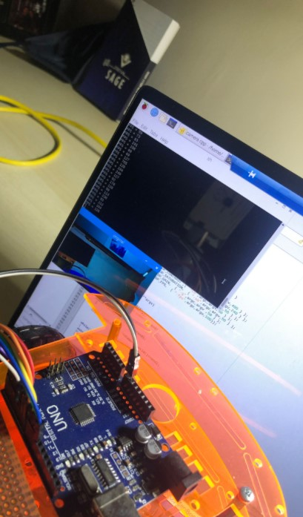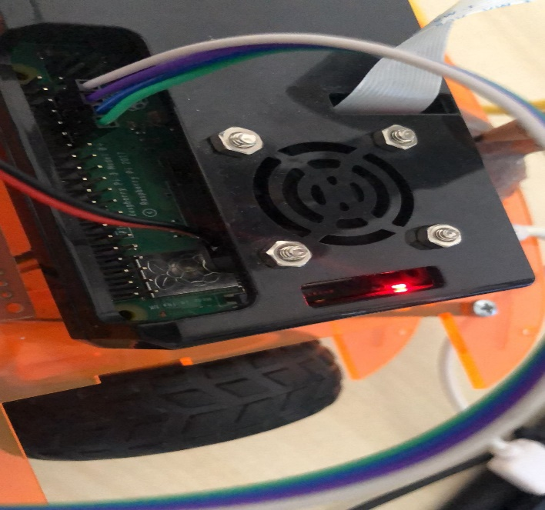

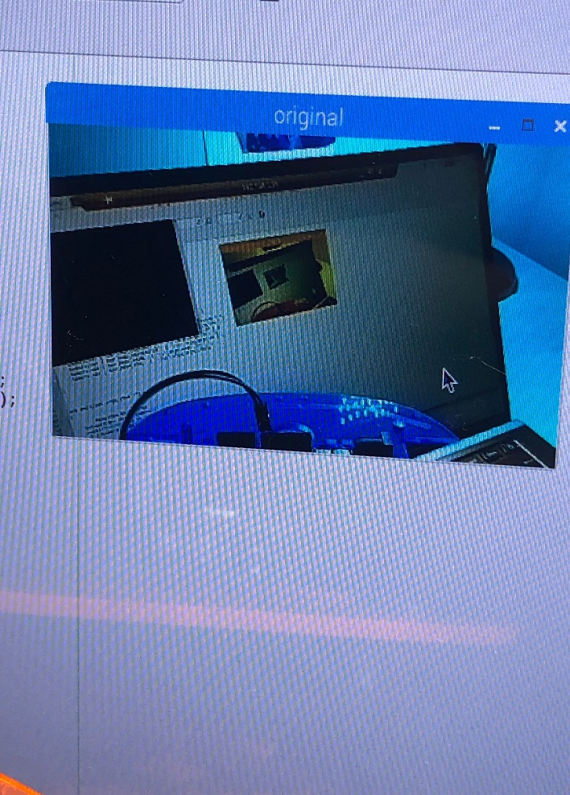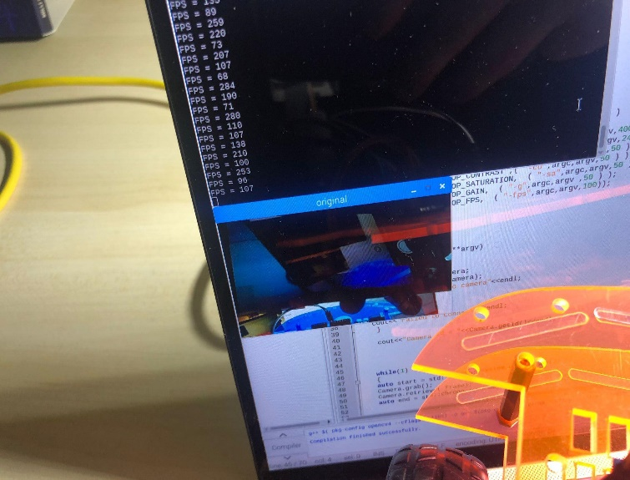

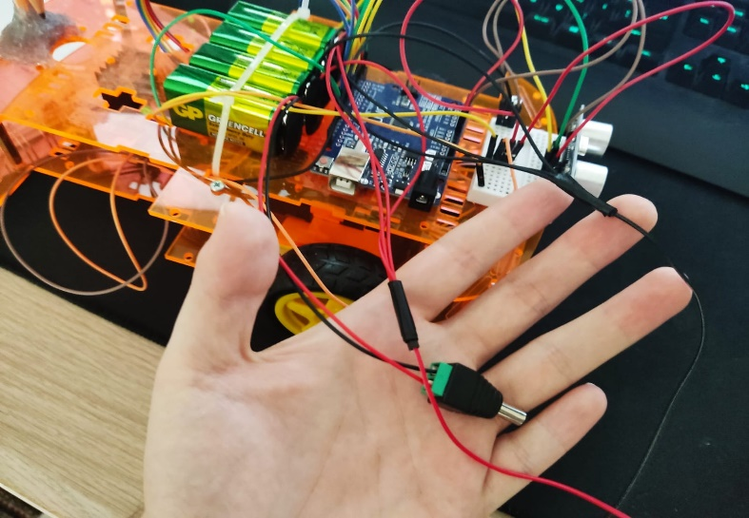

The increased prices when finding raspberries made us think. That's why we thought about buying this part for sure if we were going to use it. We had difficulty deciding on parts and components because of the prices. We investigated the drunk caster for the suitability of its balance and movement mechanism. Since there is little mobility for the wheel, but there is a lot of balance activity, the drunk wheel has become the most useful component for us.

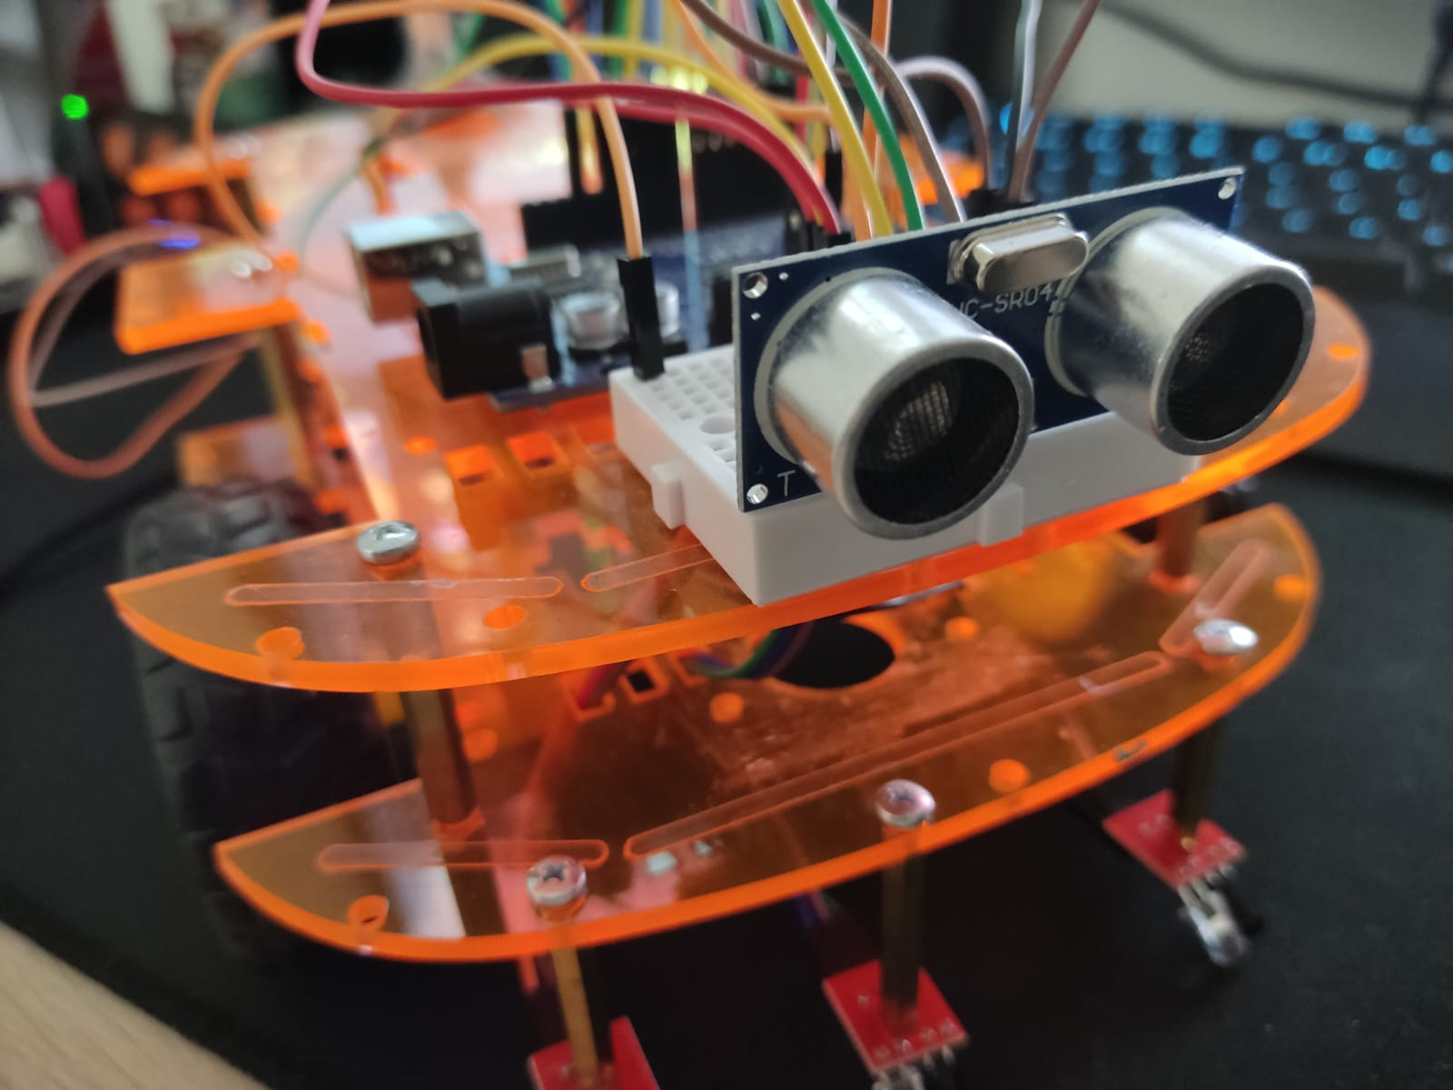

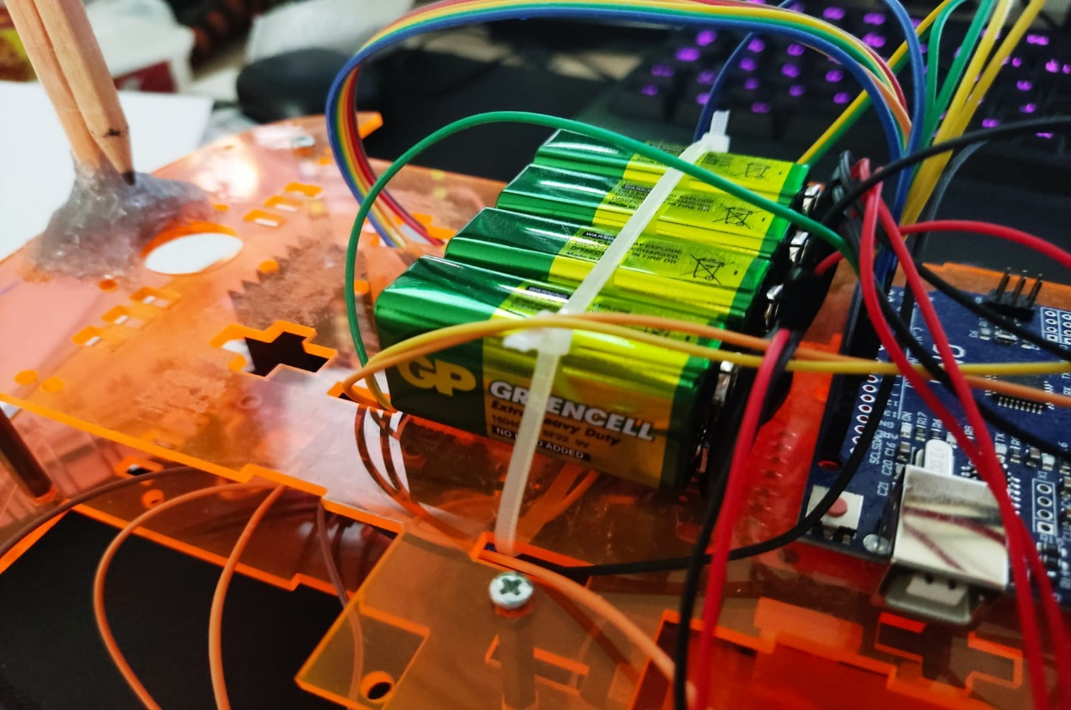

# Components:

## List of components:

* Arduino Uno (72 liras)
* Arduino uno
* L298N Motor Drive Controller Board (19 liras)
* Male-Male Male-Female Connection cable (8 liras)
* Arduino motors with tires (2*12 liras)
* Multifunctional Robot Body (15 liras)
* Arduino Distance Sensor (10 liras)
* Arduino Infrared Sensors (23 liras)
* Arduino Sensor Motherboard
* Black road on White board or Reverse
* Drunk Wheel (5 liras)

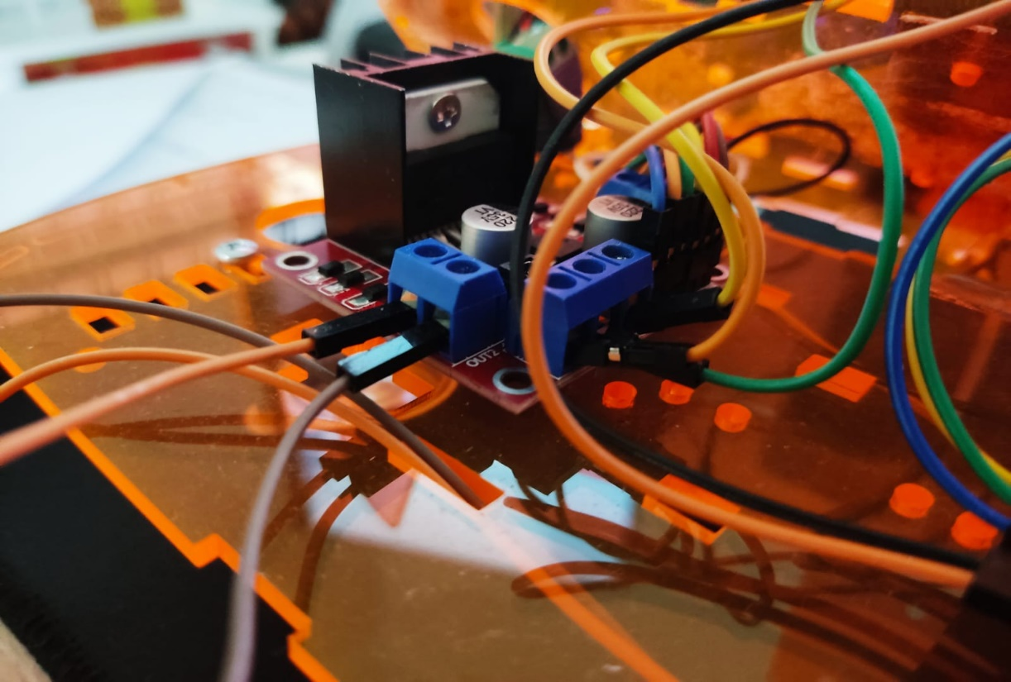

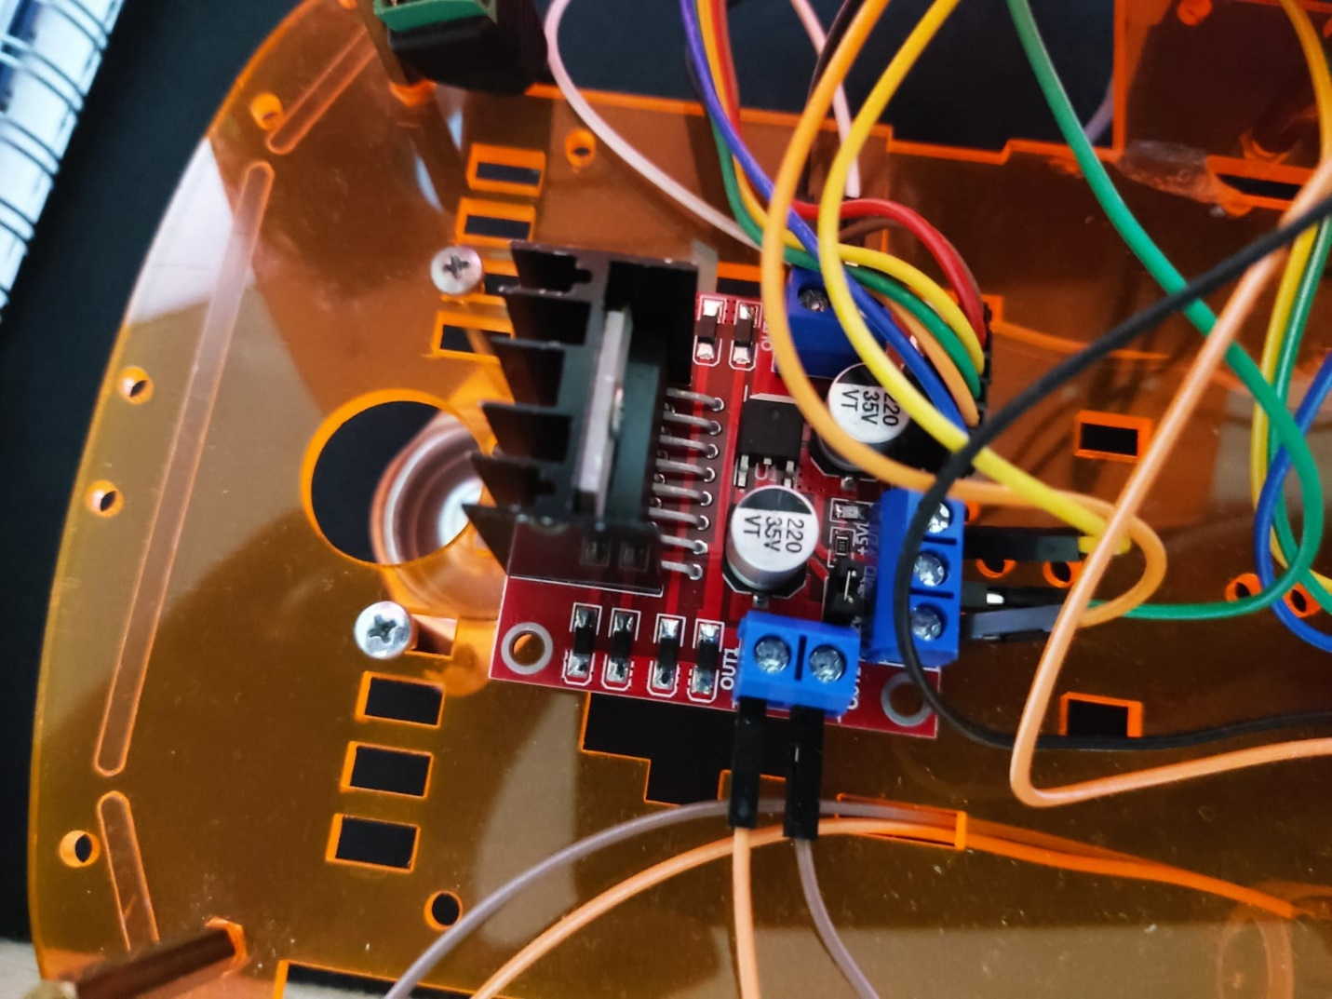

# Assemblage

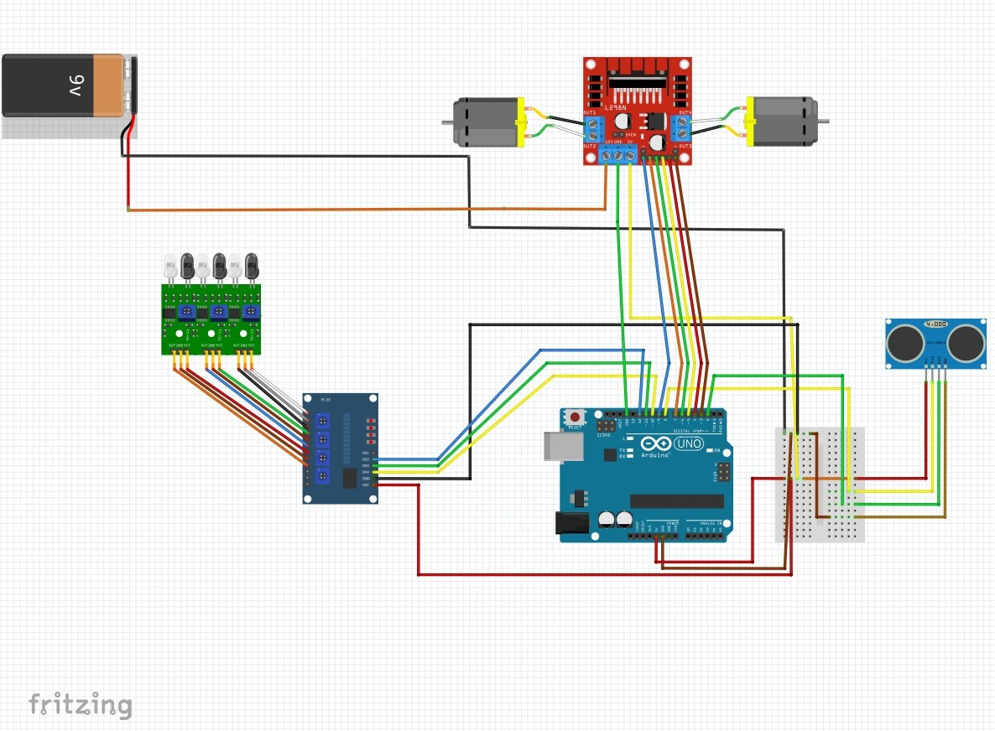

Because the dimensions of our vehicle are small, we have thought carefully about each component and selected component that are light and convenient and efficient. We have considered the weights of the components. When using cables, we have taken care of the cable colors for the same-colored cables. In order not to confuse cable color, we paid attention to the choice of products, the types of materials.

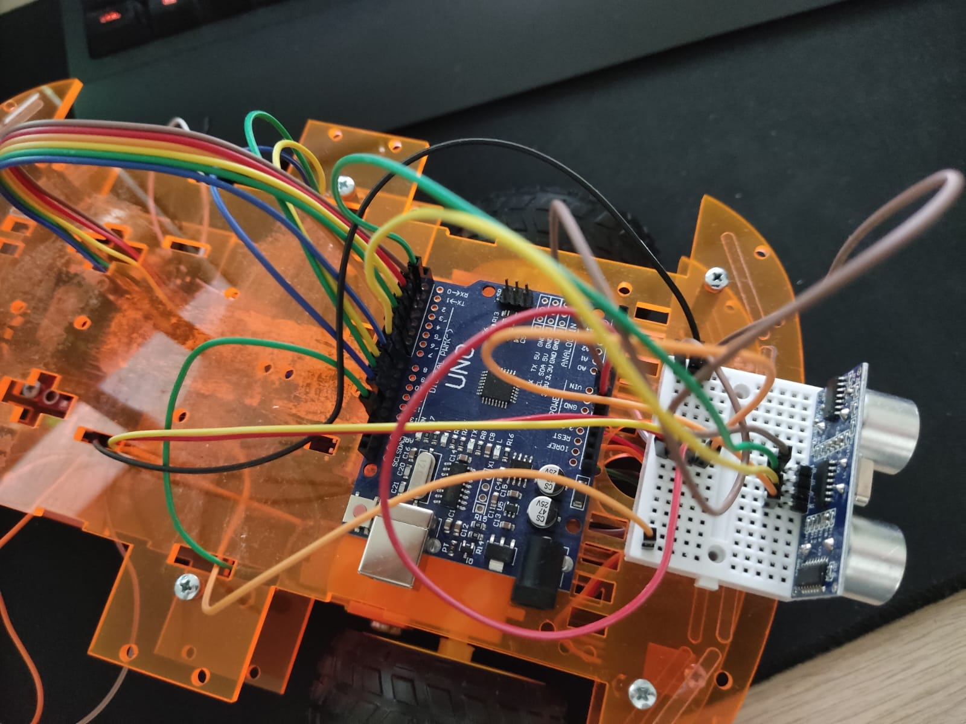

# Application Flow Chart

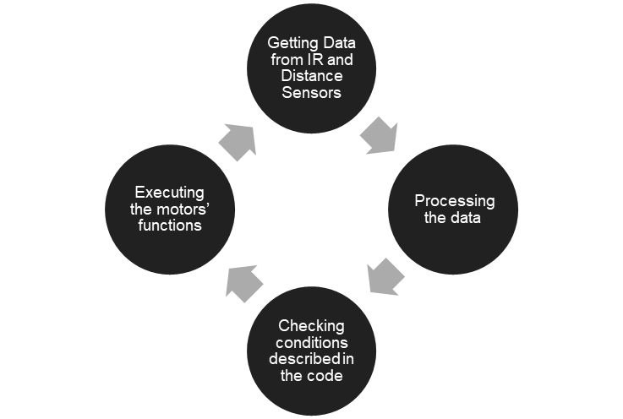

# Software

For coding we only used Arduino-IDE for this project. We started coding by including the NewPing library for Ultrasonic sensor’s functions. Later we defined the pinouts of the IR sensor, both motors and ultrasonic sensor. Then we defined a max distance for an ultrasonic sensor as 400 cm. The size of the max distance is important because we must decide a safe interval of a distance. Later we added a serial port screen for the ultrasonic sensor to see the measurements of the sensor. Then we coded the functions of our vehicle, ‘ileri’ function for proceed, ‘sag’ function for turning right, ‘sol’ function for turning left and finally ‘dur’ function for stop. For the final stage we defined sensor conditions, at the outer layer we placed safe distance conditions if the distance value is more than 30 cm initiate ‘ileri’,’sag’,’sol’ functions if the distance between 30cm and 2 cm initiate ‘dur’ function. Also, IR sensor work with binary systems ‘0’ and ‘1’. If the sensor senses white it means 0, if the sensor senses black it means 1. So, if left and right sensors sense white and middle sensor senses black initiate ‘ileri' function, if only right sensor senses black and others sense white initiate ‘sag’ function, finally, if left sensor senses black and other senses white initiate ‘sol’ function. Also, if there is an obstacle in the safe distance we read “stop” in the serial 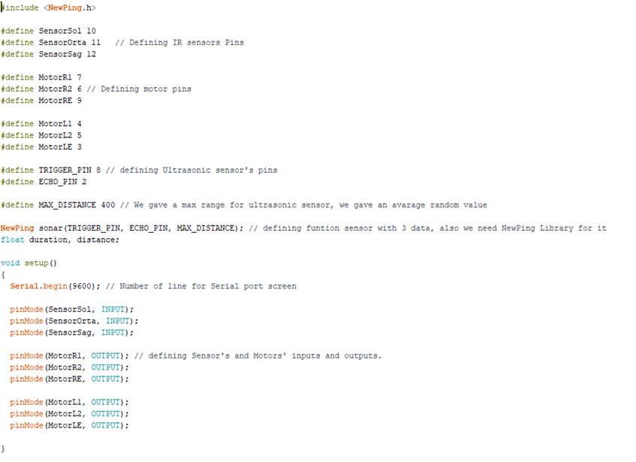port screen.

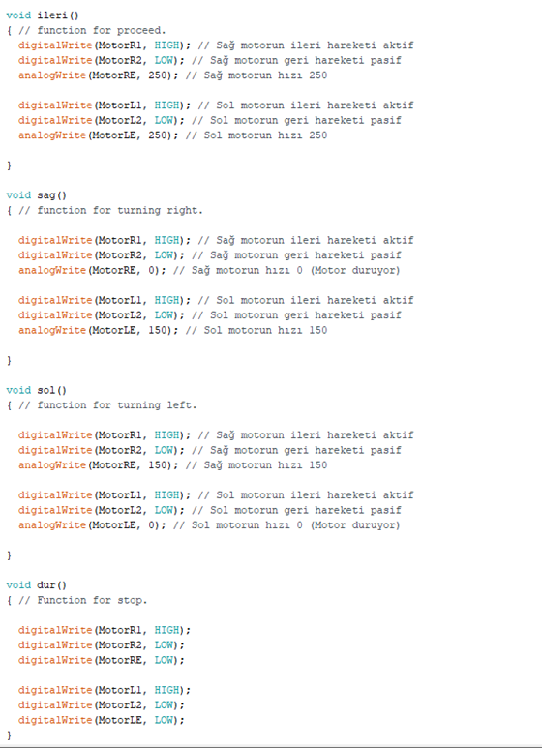

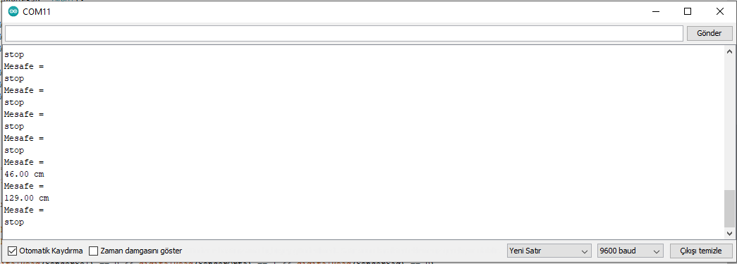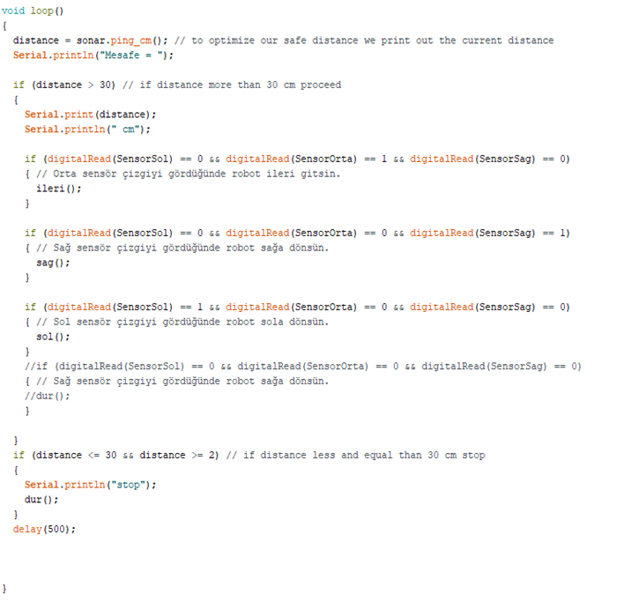

# Map Design

We adjusted the strip thickness according to the dimensions of the vehicle and the distance between the infrared sensors, added multiple U-turns to test the vehicle's capabilities, and then made the auto street drawing. After the drawing, we first tried adapting it to 4 pieces of A3 paper, but since a larger path was needed, we printed it separately on 12 A3 papers. Afterwards, we taped all of the A3s we printed out with the help of double-sided tape. He was moving the papers because there was a drunk wheel in the back, and then we strengthened it with hot glue.

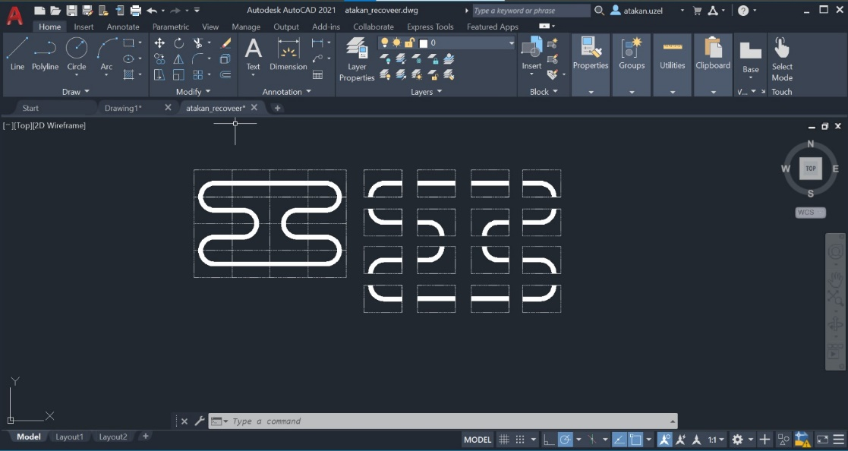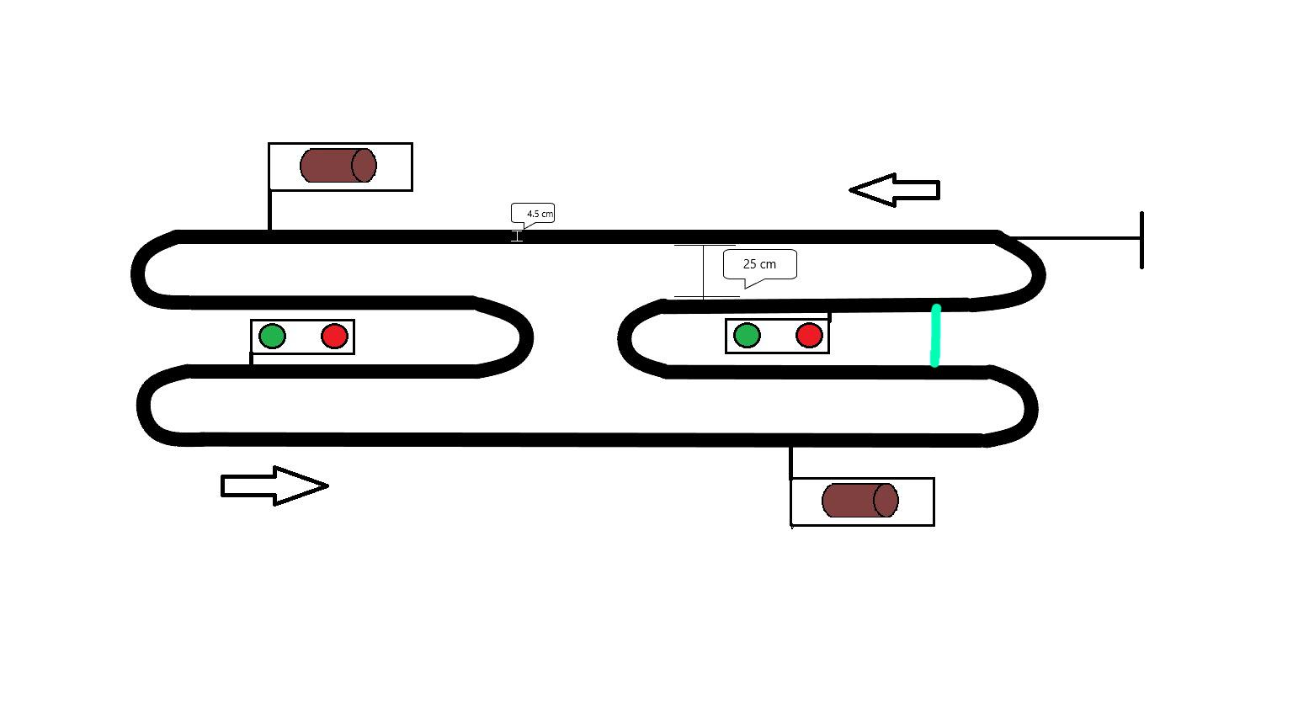

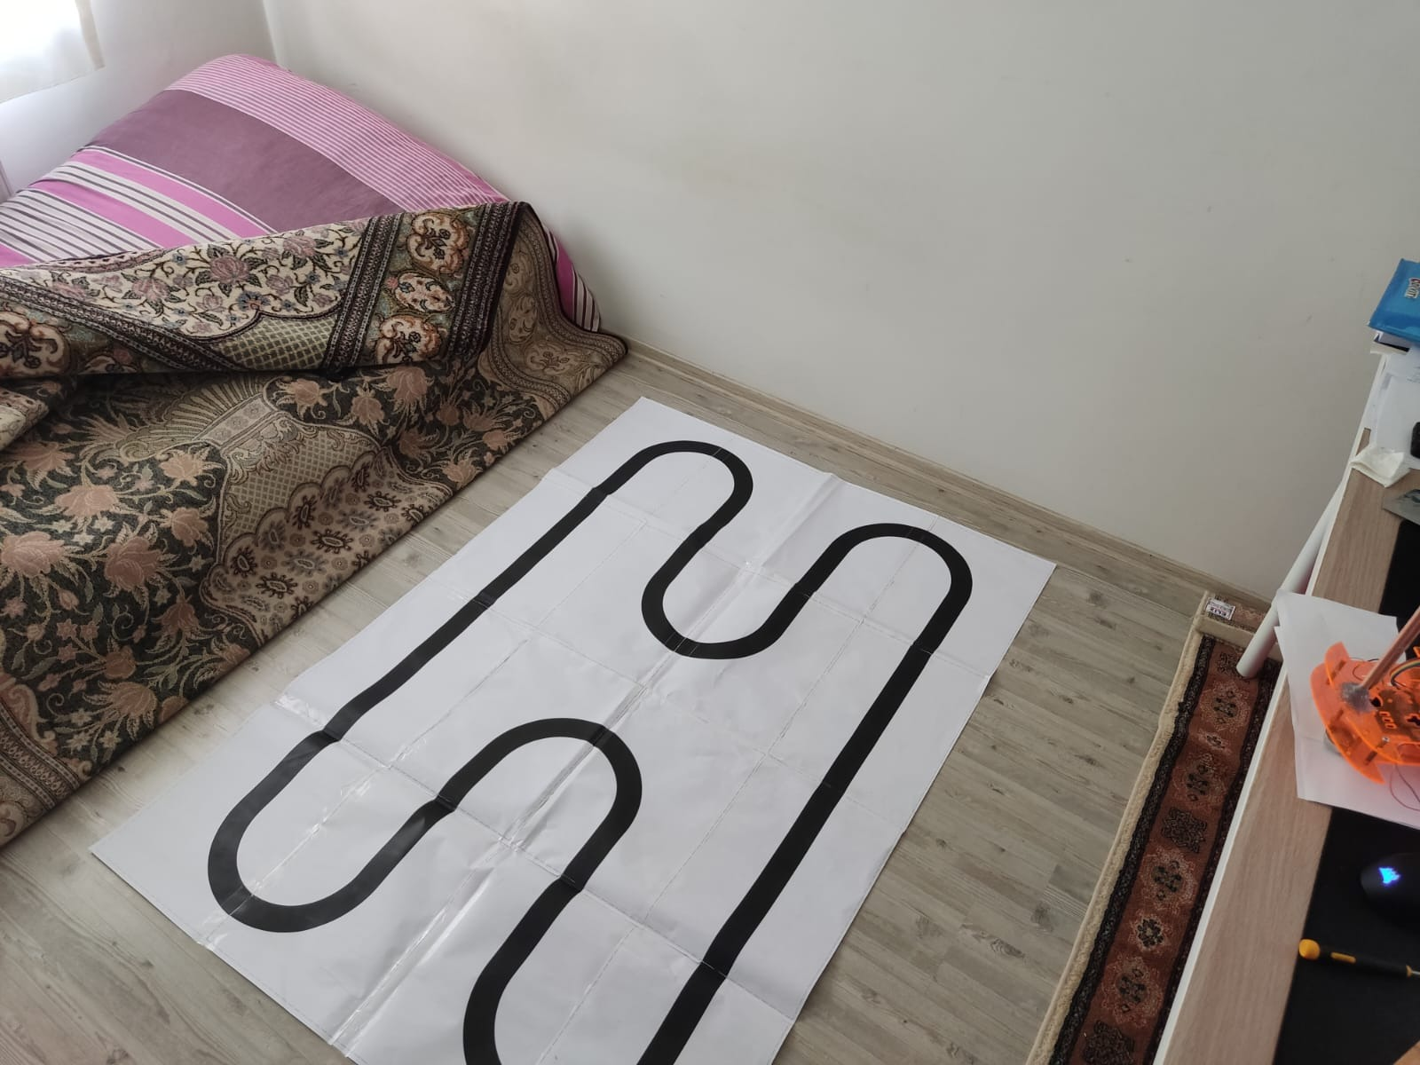

# Encountered Problems

* Components’ prices
* Implementation of components on the vehicle
* Cheap connection cables
* Wheel rotation problem
* Motor and regulator failure
* Placement and connection of Ultrasonic sensor
* Placements of batteries
* IR sensor Precision problems
* Labeling the IR sensors
* Durability of potentiometer of IR sensors
* Map design
* Calibrating the sensors according to map
* Raspberry Pi Coding and Application to the map

# Last Adjustments

Throughout the project we faced many hardships. The first motor pair we bought didn’t work properly so we had to buy a new one. Later we struggled about the energy of the vehicle, first we thought about connecting a power bank, but we couldn’t directly connect it, so we decided to use 9V batteries. We placed them on the back of the vehicle with plastic clamps and connected one of them directly to the Arduino with a DC jack and connected three other batteries on the breadboard for both regulator and IR sensors. After we tested our vehicle on a primitive road, we built a larger one which we can perform all of the functions of the vehicle. However, we couldn’t print it in one piece, so we had to use tapes and hot glue to join the pieces. Because of that our vehicle couldn’t move efficiently and stuck many times throughout the experiment. We had major problems with the IR sensors also. We couldn’t make it work on the map, so we had to do some adjustments. First, we changed the spacers of the sensors with shorter ones so that they will be perpendicularly directed to the road and stay close at the same time. Later we calibrated them with the potentiometer that was located on the control card. With these last adjustments we managed to operate our experiment.

## Adjustments’ Photos

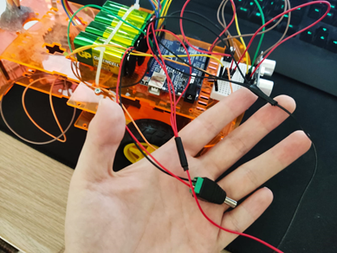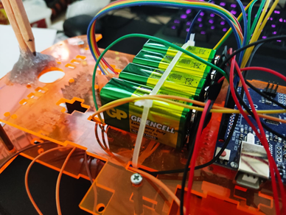

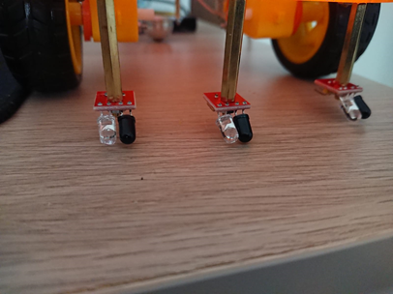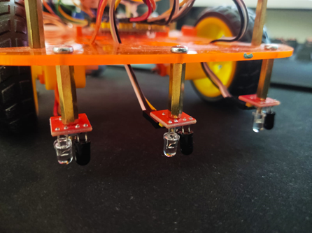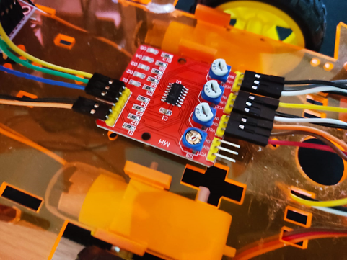

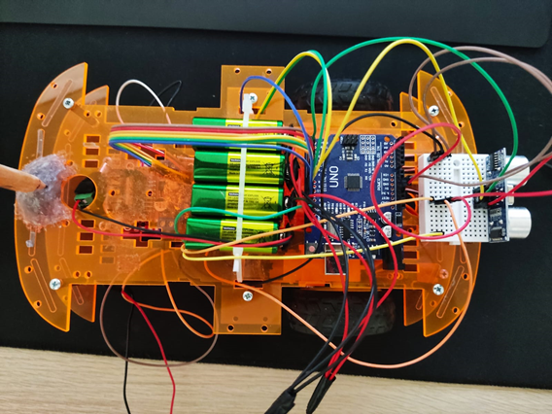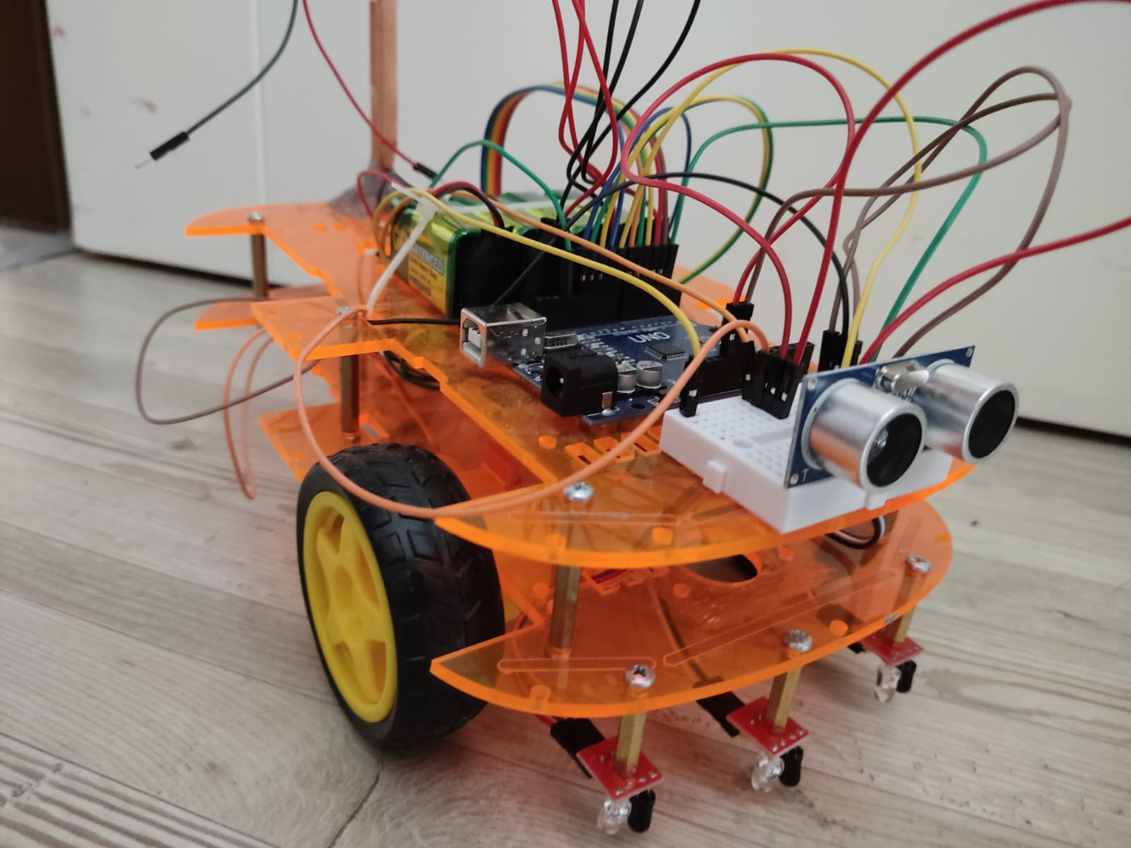

# Conclusion

As a result, with today's technology, it is easier to solve production, daily activities, or circumstances that demand key vital processes using software and hardware, without the need for humans. Besides, we built the technology and software of our autonomous car with this philosophy in mind, and we were able to perform tasks like staying in the line and doing a U-turn autonomously. Unfortunately, despite some difficulties along the way to our goal, we were able to complete the functions we desired.

Above all, using our previous expertise, we learnt how to operate the motor with Arduino and how to create communication between Arduino and Raspberry Pi while working on our project. In addition, while creating the path of our vehicle, we used the AutoCAD program to do the mapping approach. Additionally, using Opencv4 on the Raspberry Pi, it was learnt how to process images and transmit appropriate commands to Arduino. However, we were unsuccessful in this mission since the camera failed to detect the stripes during the image processing. Despite these obstacles, the project's declared goals were mostly accomplished by the conclusion.

# References

* Automated Vehicles for Safety. (n.d.). NHTSA. Retrieved June 12, 2022, from <https://www.nhtsa.gov/technology-innovation/automated-vehicles-safety>
* R. Krauss, "Combining Raspberry Pi and Arduino to form a low-cost, real-time autonomous vehicle platform," 2016 American Control Conference (ACC), 2016, pp. 6628-6633, doi: 10.1109/ACC.2016.7526714.
* Rossi, A., Ahmed, N., Salehin, S., Choudhury, T. H., & Sarowar, G. (2020). Real-time Lane detection and Motion Planning in Raspberry Pi and Arduino for an Autonomous Vehicle Prototype (Version 1). arXiv. <https://doi.org/10.48550/ARXIV.2009.09391>
* Object Detection Raspberry Pi using OpenCV Python. (2020, September 5). YouTube. <https://www.youtube.com/watch?v=Vg9rrOFmwHo>
* GitHub - opencv/opencv: Open Source Computer Vision Library. (n.d.). GitHub. <https://github.com/opencv/opencv>
* Start OpenCV with Python: Real-time Processing with Webcam. (n.d.). Udemy. <https://www.udemy.com/course/start-opencv-with-python-real-time-processing-with-webcam/>